
You get 20%
Newlyweds save 8 hours
Easy Name Change
Affiliate program

Scan to sign up!

Newlyweds are hungry for name change information! Most have never changed names before and many find the process overwhelming! Celebrants are the wedding professional most likely to be asked for this information.
Name change information should be timed for 2-4 days post-wedding. Automate an email or text message that explains when their marriage certificate arrives. Tie in your name change information here, and include your referral link!

1: SIGN UP
Get 5 FREE $39 gift cards. Valued at $195
Allow 1-2 working days for approval. We email your unique referral link
We include tips on how to integrate your referral link into your current newlywed communication. If you’re not sending the link, you’re not getting tracked and paid!

2: PROMOTE
New & Existing affiliates! Get ANOTHER 5 free gift cards when promoting!
Create an automated email campaign or making a name change email template that explains the process and includes your affiliate link
Embed the link with text. If sending an SMS, use a short URL service, like Bit.ly
Once you have your name change communication strategy set up, send it to us at askme@easynamechange.com. We'll send you 5 FREE gift cards!

3: TRACK
Tapfilliate is an independent, 3rd party tracker for clicks and sales
Login at https://easynamechange.tapfiliate.com/login
Tapfilliate tracks all traffic and resulting sales when visitors click the link on your site, email or text message. it must have the unique referral link at the end!
It looks like this: https://www.easynamechange.com/au/tws/?ref=odexmmu
You can send traffic to any page on our site, but it is only tracked when the URL must ends with your unique link, in this format: /?ref=xxxxxx

4: PAYOUT
We pay out monthly when your account reaches $100 in credit
We do this automatically, each month. Your credit never expires


FREQUENTLY ASKED QUESTIONS

Q: How do I login to my account?
Tapfilliate is an independent third part affiliate tracking platform. You need to log in via Tapfilliate’s website. Visit https://easynamechange.tapfiliate.com/login or click the QR code here

Q: Help! I can’t remember my password!
Sorry, we don’t get visibility of our affiliate’s accounts! Have a guess and see if you can remember, if not click the ‘forgot password’ link on the Tapfilliate login page.
Scan to login to your account

Q: How come I don’t have any clicks or sales?
If you have been recommending Easy Name Change but do not have any clicks, there could be 2 reasons:
- Maybe you forgot to include the unique referral link at the end of our URL. Any link to our website can be used, but you MUST include your referral link at the end. It has a format like this: /?ref=xxxxxxx.
- Your website visitors and newlyweds are not clicking the link. Make sure you are sending the link in emails, text messages and it’s on your website!

Q: I’m getting some clicks, but not as many as I expected
It’s all about timing! Most newlyweds only want name change info 1 or 2 weeks from their wedding. Interest peaks when they receive their BDM marriage certificate, which is when the process starts.
You must have quality content! You can’t just send them a link. It helps to provide 2 or 3 sentences about how the marriage certificate should be used, an overview of the process and a link to us as a time-saving service.

Q: What data does Tapfilliate reporting provide?
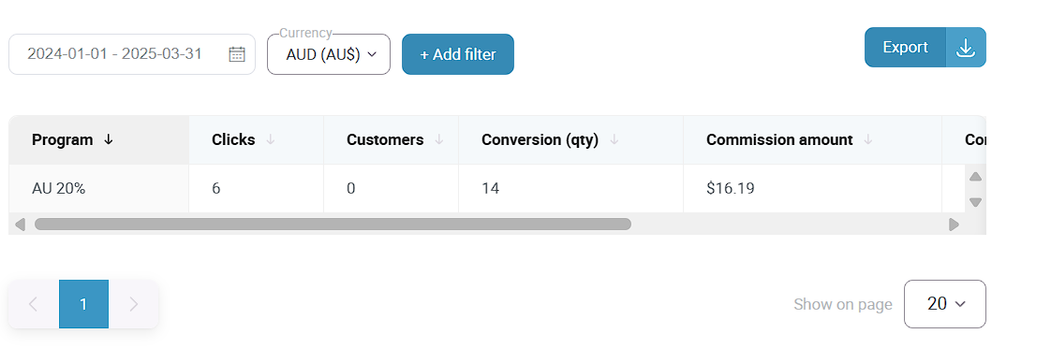
Tapfilliate shows both clicks and conversions. Be sure you set the date range. Currency must be in $AUD. You’ll see the total sales and commission due over your chosen reporting period
Need help? Speak to our marketing assistant Mahwish: askme@easynamechange.com
We can’t access your Tapfilliate account. For help contact s.naumova@tapfiliate.com

